**Distance Vector Routing Protocol (RIP)**

**Program:-**

class GFG

{

static void BellmanFord(int graph[ ][ ], int V, int E, int src)

{

**// Initialize distance of all vertices as infinite.**

int []dis = new int[V];

for (int i = 0; i < V; i++)

dis[i] = Integer.MAX_VALUE;

**// initialize distance of source as 0**

dis[src] = 0;

for (int i = 0; i < V - 1; i++)

{

for (int j = 0; j < E; j++)

{

if (dis[graph[j][0]] != Integer.MAX_VALUE && dis[graph[j][0]] + graph[j][2] <

dis[graph[j][1]])

dis[graph[j][1]] =

dis[graph[j][0]] + graph[j][2];

}

}

**//check for negative-weight cycles.**

for (int i = 0; i < E; i++)

{

int x = graph[i][0];

int y = graph[i][1];

int weight = graph[i][2];

if (dis[x] != Integer.MAX_VALUE &&

dis[x] + weight < dis[y])

System.out.println("Graph contains negative" +" weight cycle");

}

System.out.println("Vertex Distance from Source");

for (int i = 0; i < V; i++)

System.out.println(i + "\t\t" + dis[i]);

}

**// Main program**

public static void main(String[] args)

{

int V = 6; // Number of vertices in graph

int E = 8; // Number of edges in graph

/* Every edge has three values (u, v, w) where the edge is from vertex u to v. And weight of the edge is w.

int graph[][] = { { 0, 1, 10 }, { 0, 5, 8 },

{ 1, 3, 2 }, {2,1,1}, { 3, 2, -2 },

{ 4, 1, -4 }, { 4, 3, -1 }, {5, 4, 1} };

BellmanFord(graph, V, E, 0);

}

}

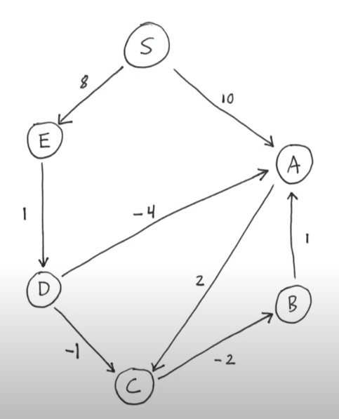

**Sample Output :-**

Vertex Distance from Source S

S 0

A 5

B 5

C 7

D 9

E 8